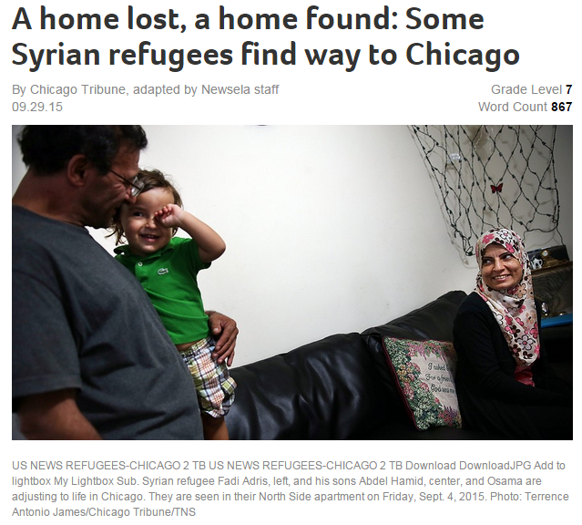
CHICAGO, Ill. — Fatima and Fadi Adris were living happily in Homs, Syria's third-largest city, where they met and were married. They made a good home for themselves. He worked as a painter, and she went to school to learn English. But in 2011, that all ended.
“We were sitting in my house when … it was destroyed over our heads,” said Fadi Adris, recalling the bomb that demolished the family home. So began their four-year flight to flee Syria's brutal civil war and find safety in Chicago. Their story of bombings, killings and refugee camps is just one of thousands coming out of the crisis in Syria, the Middle East and Europe.

No Escape From Violence
The family fled to Damascus, the Syrian capital, about 100 miles south. But within five months, the violence caught up to them. Fatima Adris’ eldest brother was shot in the street, and her father was also shot. “We were very, very afraid,” Fatima Adris said. “We hid in destroyed buildings. Whenever we would see a soldier, (my son Abdel Hamid) would hold me and shout, ‘Soldier!’”
The surviving relatives escaped by bus to Lebanon. After three years, they learned that they would be resettled in the United States, and in March, the family arrived in Chicago. The United Nations estimates that at least 250,000 people have been killed during the four-year civil war in Syria. More than 4 million Syrians are refugees in neighboring countries.

Activists Blast U.S. For Not Helping More
As European leaders scramble to find a solution to the flood of emigrants fleeing Syria, the U.S. response also has been closely watched. The United States has provided about $4 billion in humanitarian aid — the most of any nation. However, human-rights activists have criticized officials for not accepting more refugees. About 1,500 Syrian refugees have arrived in the United States. So far in 2015, 94 refugees from Syria have been resettled in Illinois, 62 of them in Chicago, according to the Refugee Processing Center, operated by the U.S. State Department, the government agency in charge of U.S. relations with other countries.
State Department officials announced that the United States expects to resettle 5,000 to 8,000 additional refugees from Syria next year. In mid-September, President Barack Obama ordered his administration to accept at least 10,000 next year. The United States accepts refugees based on need. Torture victims, medical cases and safety in the country of asylum rank high.

Syrians Seeking Asylum Have Bigger Hurdles
But Syrian Muslims figure low on the list of asylum seekers among the world’s 60 million refugees. The United States government worries that members of the Islamic State group, also known as ISIS, might slip in among those trying to escape the violence, said Bill Frelick. He is director of the refugee-rights program at Human Rights Watch. Islamic State is an extremist group. It wants to start its own country under Islamic law. Its fighters have taken over parts of Syria. Some of northern and western Iraq is also under its control.
The tragedy, he added, is that these refugees are the very people fleeing ISIS. They "want to come with their children to have a decent life where they won’t cower and live in fear.” With the United States probably accepting more refugees, the local Syrian-American community in Chicago is getting ready. The newcomers will need help with everything from finding schools to housing to emotional support.
Suzanne Akhras Sahloul, who moved to the Chicago area from Syria about 30 years ago, knows the Adrises’ pain. About a year ago, Akhras Sahloul’s cousin in Syria was killed, and around the same time, her sister-in-law’s home was destroyed during a bombing.

Helping Their Countrymen In A New Land
Eager to help, Akhras Sahloul founded the nonprofit Syrian Community Network last year. The organization assists refugee families settling in the Chicago area.
Akhras Sahloul helps a widowed mother of six who resettled on Chicago’s North Side in January. The woman, whose husband was killed, fled the ruins of her Damascus home with her children after a bombing. Two of her daughters are being treated for small fragments of metal still in their bodies.
“I remember going through the same things myself,” said Akhras Sahloul, recalling when she moved at age 10 to the United States. “I didn’t know how to play baseball or what normal American kids did.” The United States gives the resettlement agencies $1,875 for each refugee for rent, utilities and other expenses.

Covering The Cost Of Rent But Not Coats
The money doesn't go far enough. Local nonprofits have been asked to help find coats before the weather turns cold. “We imagine people from Syria won’t have coats for Chicago, so we’re asking for coats, sweaters, boots and outerwear,” said Kim Snoddy of RefugeeOne, the largest refugee resettlement organization in Illinois.
The agencies also teach refugees English, help them find jobs and provide mental health care. They are paired up with someone in their neighborhood to show them around. “They take me to the lake, they take me to the park,” said Fatima Adris, the mother from Homs. “I find everything beautiful here. We go walking, we go shopping. We don’t feel like we’re alone.”
Directions: Using information from the text (that means text evidence is required), answer the below questions.
- Explain why people are leaving Syria. Be sure your answer uses the phrase ‘push factor’.

- Explain the difficulties immigrants face when they move to another country such as the U.S.

- Explain who helps immigrants when they arrive in the U.S.

- Why do immigrants want to move to the U.S? Be sure your answer uses the term ‘pull factor’.

