Hello, learners!
The IB (and I, Ms. Synhorst) believe that all students should have some freedom and some choice in their education. We also understand all learners are different: some of you love to write, and some hate it. Some are great talkers and some are very afraid to speak in public. Some love the freedom to do whatever, and some just want to be told what to do.
For many (but not all) of this year’s assignments, I’m going to let YOU decide how you can show me what you’ve learned.
For example, I might give an assignment like “Demonstrate what you know about Frederick Douglass’ use of counter-arguments.”
You could choose to show me your learning in a creative way, in writing, in speech, or digitally.

Some possibilities include…
Creative response | Oral response | Written response | Digital response
Create a comic  Write a poem  Write a new scene to go in a creative work  Perform a song or rap  Do a “pastiche” (where you write in the STYLE of the author)  Perform a monologue or scene  Draw or paint an artwork that expresses your learning | Give a speech  Engage in a debate  Create a podcast  Interview someone (or write questions for someone to interview you) | Formal essay  Persuasive letter  Newspaper style opinion column  Compare and contrast essay  Pro and con essay  Problem-solution essay  Rhetorical analysis essay | Create a digital slideshow (like Google Slides, Powerpoint or Prezi)  Design a web page  Create a YouTube or TikTok video  Write a blog post with links or images.

General Instructions
1. Think about the question. Make some notes to help you refine your answer. Decide what you think your answer is to the question and write it down. (This step should take no more than ten minutes. If you are struggling, please ask me for help.)
2. Decide how you will demonstrate your understanding. You have many options, and what you choose will be largely dependent on whether you have a lot or a little time, whether you feel creatively inspired, whether you feel outgoing and brave or not, and whether there are still types of responses you need to complete. (This step should also not take more than ten minutes.)

Choice is hard. I know some of you will want to just be told what to do. There are 22 choices listed above. Number them, then click here. Your number is the one to try!

3. Work on the project. At this stage, you will be writing your essay, recording your podcast, drawing your cartoon, making your slideshow, etc. (This should take MOST of your time, probably 30 to 90 minutes.)
4. Reflect on your work. View it, read it, etc. Does it communicate what you want it to? Are there things you could improve or change? Spend some time editing/improving. (Perhaps 10 to 30 minutes.)
5. Submit the work via the Google Classroom. (Documents and slideshows can be easily uploaded. Video and audio files will need to have a link posted in a document. Artworks may need to be photographed and the picture uploaded. If you are planning to present a debate, speech, or do a question-and-answer with me, you will need to make an appointment and indicate your appointment time in a document. No matter what, evidence of your work has to somehow reach the Google Classroom.) This should take no more than 5 minutes.

Research task

You will also be asked to do one research task per quarter. You have the responsibility to decide what your research question is, and to get my approval first.
You will have the choice of how to present the findings of your research, but you will have to find a minimum of three academic or otherwise trustworthy sources (we will talk more about this), and a bibliography will be required.

Challenges
I have to admit that this is the first time I’ve tried something like this, and I have NO idea if it’s going to be successful.
Some challenges I can foresee include how to turn in work in a different format than usual. For example, how do you turn in a podcast? I think the easiest way to do this both for YOUR consistency and MY organization is to turn everything in via Google classroom. If it’s a document: easy. Just submit. If it’s an image? Take a photo or screenshot and upload it as a file and submit. If it’s a podcast, TikTok or YouTube video? Get the URL and paste it into a document. If you want to perform a debate or monologue live? Make an appointment in the calendar.
Another challenge is the amount of work you feel you’re putting in and grades. If you do a painting, have you done *enough* to satisfy my requirements? Well, that’s a hard thing to answer. I can’t really put together a rubric for every single kind of response, but I think we can have some common sense guidelines.

- Did it take somewhere between 30 minutes and two hours to create?
- Could someone who was not in the class look at it and understand what you were trying to say?
- Is it the best quality you are capable of?
- Did you understand your purpose as you created it, and could you clarify that purpose in a sentence or two?
If you can answer “yes” to all four of these questions, you are probably in good shape. Because this is new to me, too, I will try to be flexible and generous in my grading. I may ask you to outline your purpose in a sentence or two, just to make sure you can.
Some works that would not meet the criteria might include
- a comic that’s just one panel and made with stick figures (probably not your best work, probably took less than 30 minutes).
- A “debate” that’s just you and your friend talking, but neither of you had prepared and we can all tell that you’re making it up on the spot.
- A piece of artwork that’s just one big blue circle, and when I ask you what your purpose was, you are smart enough to invent something plausible like, “I wanted to represent the never-ending sadness of the main character.”
- A rap that’s fun, but doesn’t demonstrate your learning, like “Eh, yo, I’m Frederick Douglass, my friends call me Fred, I got more rhymes than Flint’s water got lead! EYYY!”
- An “essay” that’s just one paragraph. (Added 9/15)

Some examples
Your responses could look like any of these (or more!) (Be advised, these are *samples* to introduce the ideas, not complete assignments.

My Frederick Douglass counter-argument poem:
They said it was the money:
that in the South, they lived beautifully,
but then I saw Massachusetts.
They said it was the Curse of Ham,
but I could read, and I read the Bible,
and I saw the curse of man.
<end of sample, but I expect yours might be longer>

My Frederick Douglass counter-argument podcast:
<Insert link to audio file>
“Hey! It’s Kara, and today on my podcast, Synhorst Says, I’m going to be talking about Frederick Douglass and the art of arguing! I love to argue.
So here’s the deal: at the time of slavery, many people had all these arguments that slavery was okay, because the enslaved people were happy <insert confused sound effect>, or because it was economically important <insert sad trombone sound>, and a few other ideas to justify their monstrous behavior. But Frederick Douglass had an answer to every. Single. One. Of. Them. That’s right.” <end of sample>

My Frederick Douglass counter-argument comic.
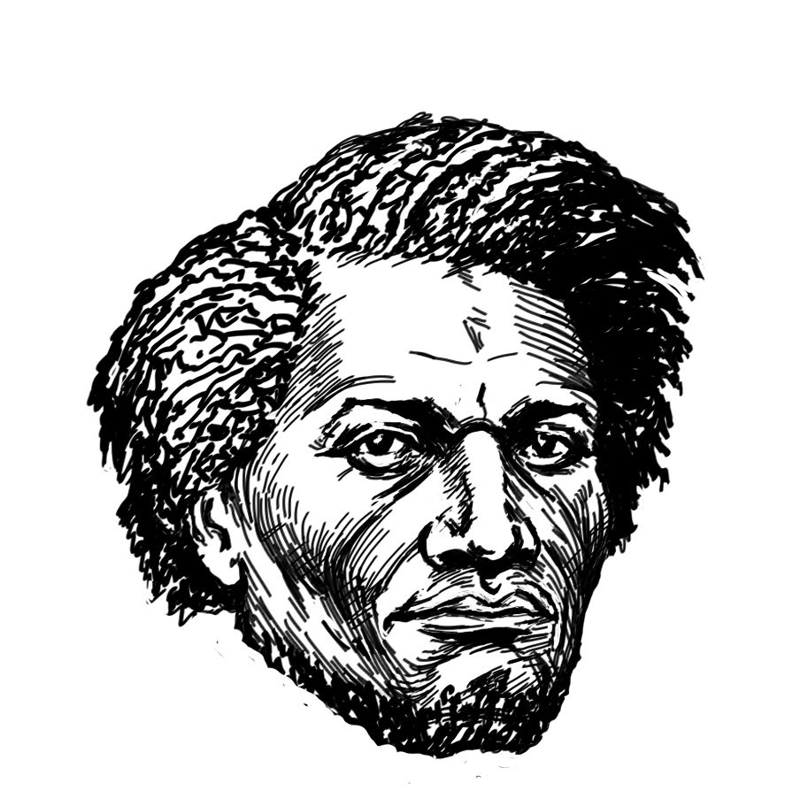  “The slaves are happy! Listen to them singing!”  “I have often been utterly astonished, since I came to the north, to find persons who could speak of the singing among slaves, as evidence of their contentment and happiness. It is impossible to conceive of a greater mistake. Slaves sing most when they are most unhappy.” | “Slaves can’t even read!”  White masters prevented slaves from learning to read. | *I copied these images from the web. If you were to do the comic option, I’d prefer that any images are your own work. I just really can’t draw. (Growth mindset note: I really can’t draw YET.)  Credit:  Colonel Sanders  https://www.deviantart.com/gushagashakun/art/Chibi-Colonel-Sanders-303375114  Frederick Douglass portrait: Thea Saks

My Frederick Douglass counter-argument writing
Frederick Douglass’ narrative contains many arguments against slavery, but he also anticipates his readers’ arguments in favor of slavery. By doing so, he is able to address them within his own work, which allows his reader to feel as though he or she can walk away from the text with no un-answered questions. The primary counter-arguments he addresses are that the enslaved people were happy and well-taken care of, that slavery was necessary to the economy, and that Black people were meant to be slaves because of the Bible.

<I think you can guess where the essay will go next: I will spend time writing about Douglass’ arguments about whether enslaved people were happy, that slavery was necessary to the economy, etc. I will probably use Douglass quotes about those things to support my points.>

Our (group work) Frederick Douglass counter-argument debate
<Note: you could link to an audio file, a video, a script, or ask to “perform” during class time.>
Viviana: “Hi, it’s me Viviana, and I worked with Angie. I’m going to be taking the side of Frederick Douglass and Angie is going to be the pro-slavery arguments in the book.”
Angie: I am not pro-slavery! It’s just for the debate. Okay, here we go.
Angie: The slaves seem well-taken care of. I was walking through Baltimore and they all seemed well-fed. Plus, once I went to dinner at a plantation, and I heard them singing songs as they walked through the forest!
Viviana: Of course the slaves in the city were well-fed. In the city you have to pretend to treat the slaves well, or you’ll be looked down on by your neighbors. On my plantation, we were given near-starvation rations. And as for the singing…

Specific tools and references
Podcast:
A podcast is an audio recording of someone talking. Some of them include interviews, recordings of other media, music, or sound effects. The best ones are pre-planned or scripted, and edited afterwards to sound their best. Here’s a great guide.
https://www.npr.org/2018/11/15/662070097/starting-your-podcast-a-guide-for-students
This is a VERY simple audio recording tool to use on a Chromebook. Many of you have phones that can record voice memos, too.
https://imclient.herokuapp.com/audiorecorder/
Comic:
Your comic can be multiple panels. If you can draw, that’s extra-great, but you will NOT be marked down for being a poor artist if you are putting effort in. You could use a simple template like this: https://images.app.goo.gl/bw7pHuCYWzVDJkUT6
Or you could try something more like a comic book: https://images.app.goo.gl/3UQgbSrRRi1DdmEj9
It does not have to be funny.

Write a poem:
It is hard to tell someone how to write a poem! Poems can be long or short, rhyme or not, be straightforward or use lots of subtle imagery and metaphors to get their point across… But if it *feels* like a poem to you, it probably is. Do your best.

New scene:
What if Frederick Douglass HAD described his escape? What if Beyoncé had included a scene that included “Becky with the good hair?” What would those scenes look like? You could write them, describe them, “storyboard” them… Just keep in mind that your purpose is still to demonstrate understanding, not just to be creative.

Perform a song or rap:
How could you perform a song about your understanding? Well, can you sing? If not, could you write lyrics that express it? Can you play guitar or keyboard? This is a great opportunity for group work. Personally, I love to do songs based on existing songs, like Weird Al Yankovich does. If we listened to the episode of Seeing White about Bhagat Singh Thind, maybe I would think of the Bruno Mars song “Grenade” (it’s old, I know) and change the lyrics to “I’d look down on a caste for you. I’d pass the paper bag test for you…”

Do a “pastiche”:
This can be challenging, because to do a pastiche of an author’s work, you have to understand what they sound like. Have you ever seen an actor or comedian impersonate someone? They change their voice and often face and hand gestures to be more like the person they are pretending to be. To write in the style of an author is hard, because you have to pay careful attention to how THEY write. Do they use slang? High-register language? Do they have long sentences or short ones? This can work very well for poetry, which has a style that is sometimes easier to detect. Check in with me if you need help on this one.

Perform a monologue or scene:
After watching Hamilton, could you perform a monologue you’ve written for Eliza Schuyler? You’d plan it out by writing it first, then record yourself (or perform live) saying something like, “I may have written myself out of the narrative, but that doesn’t mean I stopped living. During those years between Alexander’s letter about his affair and our son’s death, I wrote regularly to Angelica…”
Draw or paint an artwork that expresses your learning
Can you paint a portrait of James Baldwin’s face*? What symbolic objects would be in the background? Would he be on a map of France, but looking towards the U.S.? Can you sculpt Beyonce’s bat, and put on it all the faces she probably REALLY wanted to smash? What’s your art? Can you express your learning through it? Great!
*We may not end up doing James Baldwin this semester. I got so excited about all the choices that I put more texts than we probably have time for.

Give a speech
You’ll have to write out in advance what you want to say, or AT LEAST write an outline and have a good idea of what you plan to say. It is a good idea to write your main points on notecards or even on the Notes app of your phone. It is NOT smart to try to write every single word on the cards or app. A speech should be delivered to the people watching, and they will feel bored and alienated if you don’t look up at them, which is hard to do if you’re reading.

Engage in a debate
This is a great one to do as a group project. Usually a debate involves two people. There’s a central question, like “is it important to examine whiteness?” The first person might be “pro,” and they will try to make an argument why it is important. The second person will spend a shorter time saying why one or more of those arguments is not good. Then they will spend time making an argument against the idea. Then the first person will argue against one of their points. There’s a very specific format for how to do this (you can look up “Lincoln Douglass debates if you like), but I encourage you and your partner to plan what works best for you and gets your ideas across most effectively.

Interview someone (or write questions for someone to interview you)
You can do this in a real way (like interviewing your grandma about how race or gender impacted her, to demonstrate something about the Seeing White podcast), or you can do this in a fictional way (you write interview questions for Frederick Douglass or Beyoncé, then you or a friend pretends to be that person and answers the questions).
If you choose the first type, it’s important that you prepare by writing thoughtful questions. If you do the second kind, it’s most important to make sure the answers explore the topic clearly and carefully.

Formal essay
You have probably written these before. They begin with an attention-getter, introduce the issue, then state a formal thesis. You might include three pieces of evidence to support your thesis.
Then, the following paragraphs explore the evidence, usually in a similar format: Topic sentence, quote or paraphrase, and commentary on the evidence.
The essay concludes by saying how you’ve supported your thesis and what the reader should learn or take away from this reading.

Persuasive letter
This letter could be addressed to anyone. It could be to the host of the podcast, to Lin-Manuel Miranda, to Frederick Douglass, to Beyoncé, to your Grandpa, to me… The only trick is that the letter should try to convince someone to do or believe something.
Newspaper style opinion column
Sometimes in formal writing, teachers tell you not to use your opinion, or to say “I.” Forget that! An opinion column is all about you and your point of view. Here are some very interesting ones to read so you can see what they’re like. https://www.nytimes.com/2017/12/28/opinion/2017-favorite-columns.html

Rhetorical analysis essay
I would really encourage you to try this one. This is the kind of essay that is on the SAT. Many essays are like, “Here’s a Tim Smith essay on school uniforms. What does Tim think? What do you think? Use examples.”
This is the OPPOSITE. It doesn’t CARE about your opinion. It asks you to look only at the writer’s writing and language choices and examine them. Are they effective? Why did they use the language they chose? Look at how they use evidence, such as facts or examples, to support claims. How do they use reasoning to develop ideas and to connect claims and evidence? How do they stylistic or persuasive elements, such as word choice or appeals to emotion, to add power to the ideas expressed? Your essay should not explain whether you agree with the author’s claims, but rather explain how they build an argument to persuade their audience. It might be useful to look at the College Board site.

Create a digital slideshow:
You can use Google Slides, Powerpoint or Prezi. For me, Google Slides makes the most sense, since we use Google for almost everything else. But Prezi can be aesthetically appealing. You will want to use both text and images to express your understanding.
Design a web page:
My preferred platform is probably Google Sites, but if you’re in ITGS, you can use whatever feels comfortable for you.
Create a YouTube or TikTok video
I’m really excited to see what you come up with.
I think people are doing really creative stuff, and you could use something like this as a model. https://www.tiktok.com/@sundayschooldropout/video/6826476901771627782?lang=en
I loved a student’s “Powtoon” created on Powtoon.com.
Write a blog post with links or images.
Okay, a blog post is pretty much just a written response, but if you include some links and images, it counts as a digital response! It also has a tendency to be more informal.

I suggest that a slideshow, web page, or short essay are the easiest ways to present these findings.
Some of your research topics will not lend themselves to academic journals. They might be too new, for example. But as much as we can, we will be looking for sources that are established, that have a name associated with them, and that pass our best information literacy tests.

