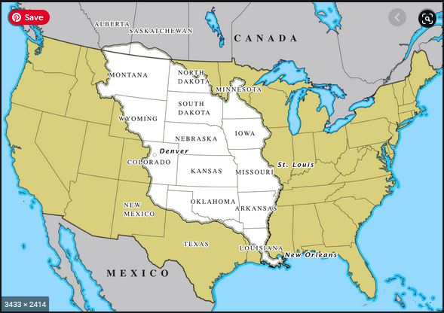
Sources: Natural Earth and Portland State University (https://gist.github.com/wboykinm/05756ac2e625bae9ed81)

A man named Napoleon was the ruler of France in the early 1800’s. He was fighting many wars, and needed money.

France owned all the land in white on the map. They said they owned it even though Native Americans lived there and had lived there for thousands of years.

Thomas Jefferson was President of the United States in 1803, and the U.S. bought the land in white for $15 million dollars. It is called the Louisiana Purchase. The present state of Louisiana was part of it.

Jefferson sent a group of people who spent two years exploring the area. It was led by two men, Meriwether Lewis and William Clark. It is known as the Lewis and Clark Expedition. An enslaved man named York and a Native American woman named Sacagawea helped the Lewis and Clark Expedition be successful.

